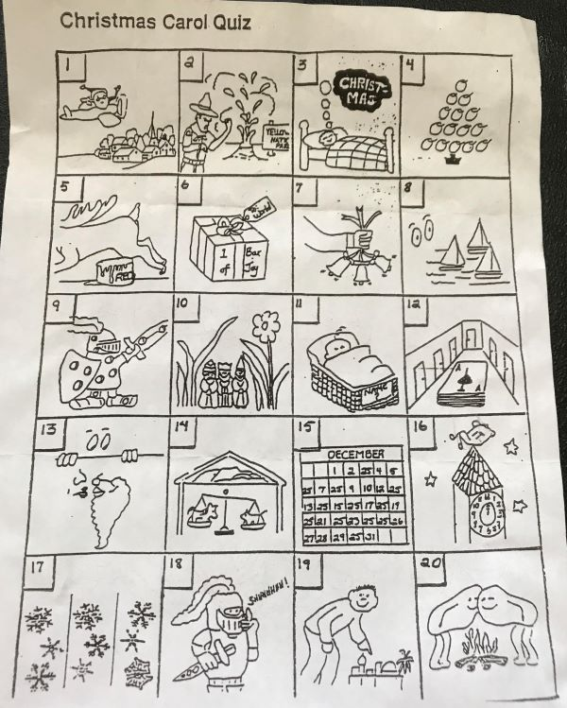

- Santa Claus is Coming to Town
- O Come, O Come, Emmanuel
- I’m Dreaming of a White Christmas
- O, Christmas Tree!
- Rudolph, the Red-Nosed Reindeer
- Joy to the World
- I Heard Three Bells on Christmas Day
- I Saw Three Ships Come Sailing By
- O, Holy Night.
- We Three Kings
- What Child is This?
- Deck the Halls
- I Saw Mommy Kissing Santa Claus
- Away in a Manger
- The 12 Days of Christmas
- It Came Upon a Midnight Clear
- Let it Snow!
- Silent Night
- O, Little Town of Bethlehem
- Chestnuts Roasting on an Open Fire

